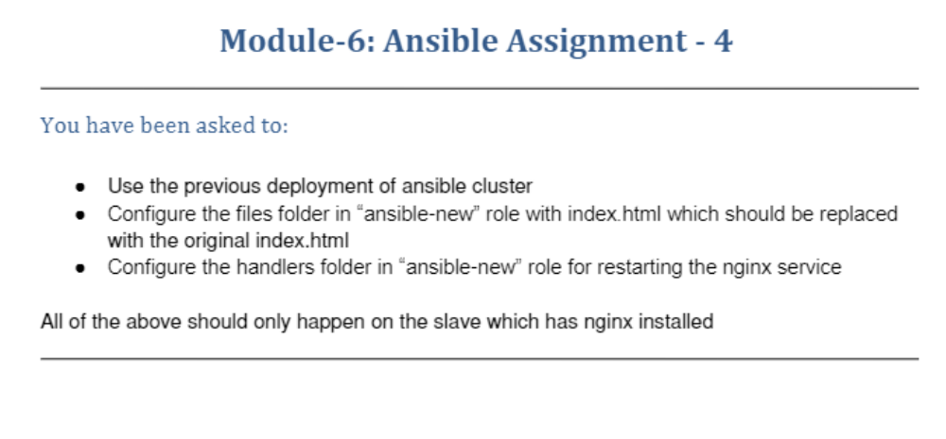
ubuntu@ip-172-31-16-129:~/ansible/roles$ sudo ansible-galaxy init ansible-new --offline
- Role ansible-new was created successfully
ubuntu@ip-172-31-16-129:~/ansible/roles$ cd ansible-new/
ubuntu@ip-172-31-16-129:~/ansible/roles/ansible-new$ ls
README.md defaults files handlers meta tasks templates tests vars
ubuntu@ip-172-31-16-129:~/ansible/roles/ansible-new$ cd files
ubuntu@ip-172-31-16-129:~/ansible/roles/ansible-new/files$ ls
ubuntu@ip-172-31-16-129:~/ansible/roles/ansible-new/files$ sudo vi index.html
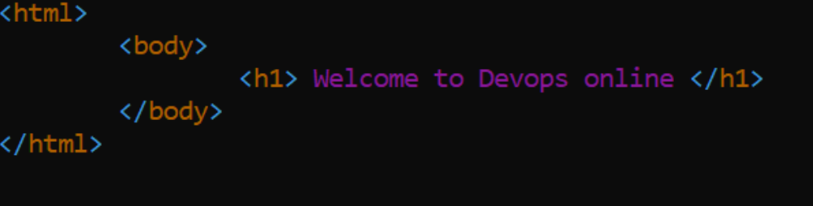
ubuntu@ip-172-31-16-129:~/ansible/roles/ansible-new$ cd handlers/
ubuntu@ip-172-31-16-129:~/ansible/roles/ansible-new/handlers$ ls
main.yml
ubuntu@ip-172-31-16-129:~/ansible/roles/ansible-new/handlers$ sudo vi main.yml
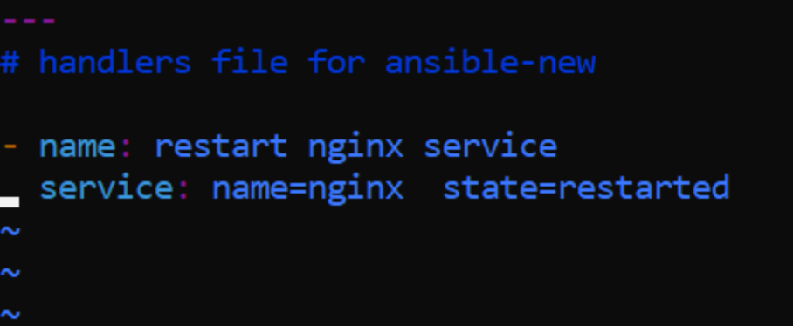
ubuntu@ip-172-31-16-129:~/ansible/roles/ansible-new/handlers$ cd ..
ubuntu@ip-172-31-16-129:~/ansible/roles/ansible-new$ cd ..
ubuntu@ip-172-31-16-129:~/ansible/roles$ cd ..
ubuntu@ip-172-31-16-129:~/ansible$ sudo vi hosts
ubuntu@ip-172-31-16-129:~/ansible$ ansible-playbook -i hosts myplaybook.yaml
ubuntu@ip-172-31-16-129:~/ansible/roles/ansible-new/handlers$ cd ..
ubuntu@ip-172-31-16-129:~/ansible/roles/ansible-new$ cd ..
ubuntu@ip-172-31-16-129:~/ansible/roles$ cd ..
ubuntu@ip-172-31-16-129:~/ansible$ sudo vi hosts
ubuntu@ip-172-31-16-129:~/ansible$ ansible-playbook -i hosts myplaybook.yaml

PLAY [install nginx] *****************************************************************************************************

TASK [Gathering Facts] ***************************************************************************************************
ok: [Test1]

TASK [ansible-new : Install nginx] ***************************************************************************************
changed: [Test1]

PLAY RECAP ***************************************************************************************************************
Test1 : ok=2 changed=1 unreachable=0 failed=0 skipped=0 rescued=0 ignored=0
ubuntu@ip-172-31-16-129:~/ansible$

